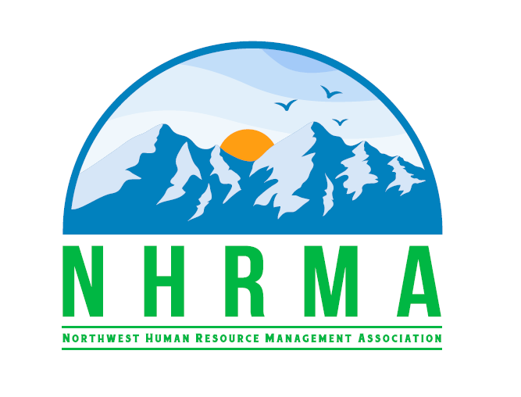

Kristina Bader, Foundation Director

[Foundation@nhrma.co](mailto:Foundation@nhrma.co)

<http://nhrma.shrm.org>

Look for us on: [LinkedIn](https://www.linkedin.com/company/nhrma--northwest-human-resource-management-association/?viewAsMember=true), [Twitter](https://twitter.com/NHRMA72), [Facebook](https://www.facebook.com/nhrma)



Gayle Young, Professional Development Director

[Development@nhrma.co](mailto:Development@nhrma.co)

<http://nhrma.shrm.org>

Look for us on: [LinkedIn](https://www.linkedin.com/company/nhrma--northwest-human-resource-management-association/?viewAsMember=true), [Twitter](https://twitter.com/NHRMA72), [Facebook](https://www.facebook.com/nhrma)



Stacey Scalf, Partnership Director

[Partnership@nhrma.co](mailto:Foundation@nhrma.co)

<http://nhrma.shrm.org>

Look for us on: [LinkedIn](https://www.linkedin.com/company/nhrma--northwest-human-resource-management-association/?viewAsMember=true), [Twitter](https://twitter.com/NHRMA72), [Facebook](https://www.facebook.com/nhrma)



Roshelle Pavlin, President

[President@nhrma.co](mailto:President@nhrma.co)

<http://nhrma.shrm.org>

Look for us on: [LinkedIn](https://www.linkedin.com/company/nhrma--northwest-human-resource-management-association/?viewAsMember=true), [Twitter](https://twitter.com/NHRMA72), [Facebook](https://www.facebook.com/nhrma)



Chance Brimhall, Vice President

[VicePresident@nhrma.co](mailto:VicePresident@nhrma.co)

<http://nhrma.shrm.org>

Look for us on: [LinkedIn](https://www.linkedin.com/company/nhrma--northwest-human-resource-management-association/?viewAsMember=true), [Twitter](https://twitter.com/NHRMA72), [Facebook](https://www.facebook.com/nhrma)



Nancy Miller, Past President

[PastPresident@nhrma.co](mailto:PastPresident@nhrma.co)

<http://nhrma.shrm.org>

Look for us on: [LinkedIn](https://www.linkedin.com/company/nhrma--northwest-human-resource-management-association/?viewAsMember=true), [Twitter](https://twitter.com/NHRMA72), [Facebook](https://www.facebook.com/nhrma)



Renee Larsen, Secretary

[Secretary@nhrma.co](mailto:Secretary@nhrma.co)

<http://nhrma.shrm.org>

Look for us on: [LinkedIn](https://www.linkedin.com/company/nhrma--northwest-human-resource-management-association/?viewAsMember=true), [Twitter](https://twitter.com/NHRMA72), [Facebook](https://www.facebook.com/nhrma)



Ophelia Yan, Treasurer

[Treasurer@nhrma.co](mailto:Treasurer@nhrma.co)

<http://nhrma.shrm.org>

Look for us on: [LinkedIn](https://www.linkedin.com/company/nhrma--northwest-human-resource-management-association/?viewAsMember=true), [Twitter](https://twitter.com/NHRMA72), [Facebook](https://www.facebook.com/nhrma)



Sallie Stuvek, Awards & Recognition Director

[Awards@nhrma.co](mailto:Awards@nhrma.co)

<http://nhrma.shrm.org>

Look for us on: [LinkedIn](https://www.linkedin.com/company/nhrma--northwest-human-resource-management-association/?viewAsMember=true), [Twitter](https://twitter.com/NHRMA72), [Facebook](https://www.facebook.com/nhrma)



Charla Brown, College Relations Director

[CollegeRelations@nhrma.co](mailto:CollegeRelations@nhrma.co)

<http://nhrma.shrm.org>

Look for us on: [LinkedIn](https://www.linkedin.com/company/nhrma--northwest-human-resource-management-association/?viewAsMember=true), [Twitter](https://twitter.com/NHRMA72), [Facebook](https://www.facebook.com/nhrma)



Karlina Christensen, Communications Director

[Communications@nhrma.co](mailto:Communications@nhrma.co)

<http://nhrma.shrm.org>

Look for us on: [LinkedIn](https://www.linkedin.com/company/nhrma--northwest-human-resource-management-association/?viewAsMember=true), [Twitter](https://twitter.com/NHRMA72), [Facebook](https://www.facebook.com/nhrma)



Alan Cabelly

[Specialprojects@nhrma.co](mailto:Specialprojects@nhrma.co)

<http://nhrma.shrm.org>

Look for us on: [LinkedIn](https://www.linkedin.com/company/nhrma--northwest-human-resource-management-association/?viewAsMember=true), [Twitter](https://twitter.com/NHRMA72), [Facebook](https://www.facebook.com/nhrma)