**SCRIPT**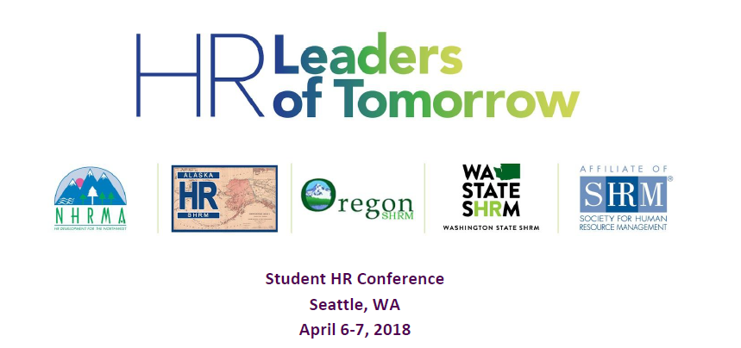

**Friday Evening, April 6, 2018**

|  |  |  |  |
| --- | --- | --- | --- |
| **Time** | **Leader** | **Action** | **Talking Points** |
| 5:00 PM | - | Set-Up Registration | - |
| 5:30 PM | - | Registration Opens/Guests Begin Arriving | - |
| 6:00 PM | - | Networking and hor d’oeuvres | - |
| 6:25 PM | Markus Smith | Welcome everyone and introduce Shannon Swift | Introduce self and welcome group and thank everyone for attending.  Review schedule for evening.  Give away Door Prize  Introduce Shannon Swift |
| 6:30 PM | Shannon Swift | Opening Keynote | “HR: The Secret Super Power” |
| 8:00 PM | - | Networking Event Concludes | Attendees our on their own for the evening. |

**Saturday, April 7, 2018**

|  |  |  |  |
| --- | --- | --- | --- |
| **Time** | **Leader** | **Action** | **Talking Points** |
| 7:00 AM | - | Set-Up Registration | - |
| 7:30 AM | - | Registration Opens | - |
| 8:00 AM | Markus Smith | Welcome Remarks and Introductions | Welcome attendees.  Introduce and invite to podium:  Rochelle Pavlin, SHRM-SCP, SPHR  2018 NHRMA President  Rochelle will then introduce and invite to podium:  Dianna Gould, SHRM-SCP, CAE  SHRM Field Services Director (West) |
| 8:20 AM | Markus Smith | Announcements | Download Whova to your device  Get Your Social On for a chance to Win $250  Give Away First Door Prize |
| 8:25 AM | Markus  Smith | Introduce Opening Speaker | Nancy Kasmar  Compensation Connections |
| 8:30 AM | Nancy Kasmar | Opening Keynote | Topic: “Oh, The Places You’ll Go” |
| 9:30 AM | - | Networking Break | - |
| 9:45 AM | Markus  Smith  &  Juanita  Roesler | Concurrent Sessions | Markus will introduce:  1A “Demystifying Key Areas of Employment Law”  Aviva Kamm  Stokes Lawrence, PS  Juanita will introduce:  1B “Business Strategy and the Role of HRM in Strategic Planning”  Dave Rambow  Wayland Baptist University |
| 10:45 AM | - | Networking Break | - |
| 11:00 AM | Markus  Smith  &  Juanita  Roesler | Concurrent Sessions | Markus will introduce:  2A “HR and the Numbers”  Rick Howell  Howell Management Consulting  Juanita will introduce:  2B “Workforce Transformations & Conducting Employee Notification Meetings”  Natallie Miller  Lee Hecht Harrison |
| 12 NOON | Markus Smith | LUNCH | Welcome everyone.  Give away door prize. |
| 12:55 PM | Markus  Smith | Introduce Lunch Speaker | Cindy Pain  Lee Hecht Harrison |
| 1PM | Cindy Pain | Lunch Keynote | “My Profile. My Story. My Brand. Working with Linkedin.” |

**Saturday, April 7, 2018, Cont….**

|  |  |  |  |
| --- | --- | --- | --- |
| **Time** | **Leader** | **Action** | **Talking Points** |
| 2:30 PM | Markus Smith  &  Juanita  Roesler | Concurrent Sessions | 3A “Chapter Management Session” for current and future chapter leaders  Moderator: Charla Brown  3B Resume Review/Linkedin Review |
| 3:30 PM | - | Networking Break | - |
| 3:45 PM | Juanita  Roesler | Returning Student Panel  “What I Wish I Had Known Then” | Charla will introduce panel participants. |
| 5:00 PM | Markus  Smith | HR Games | Moderator: ?  Judges: Marilyn Hoppen  Score Keeper: ? |
| 6:00 PM | Markus  Smith | Conclude | Thank everyone for attending  Door Prizes |