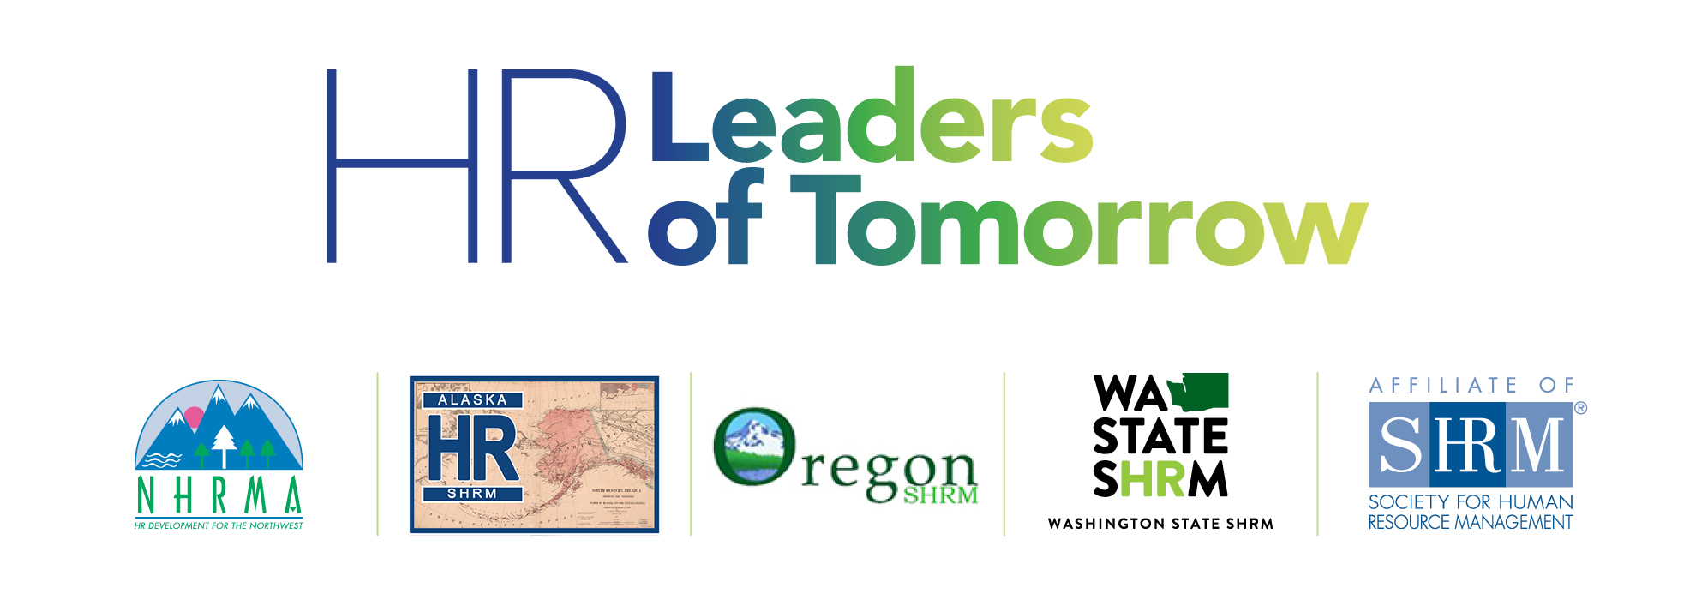

**Student HR Conference**

**Seattle, WA**

**April 6-7, 2018**

Hello HR Student Colleagues!

It is with great excitement that we await the conference in Seattle just a few days away and we wanted to reach out with some helpful information in advance to help you plan your trip. Please review these details below and if you have any questions at all, you are welcome to text/call 907.465.7272 for assistance. The event is full of engaging activities & we are confident that it will provide an experience to remember.

In order of priority, please be sure to check out details in the content that follows on subsequent pages:

* Download the Whova conference app to your device to view the agenda & plan your schedule.
* Get your social media on for a **chance to win $250**! The attendee with the best social media post during the week of the conference will ***win $250 VISA CASH CARD!***  See below for details.
* Bring your laptop, mobile device, and three hard copies of your resume for interactive sessions.
* Create a LinkedIn profile before 4/7 to get the most out of one of our keynote addresses.
* Share your road trip and/or flight experiences! We want to hear all about your journey to Seattle!
* Get excited for an HR Games showdown (no preparation required). Bring it!
* Pack appropriately for the weather and the event - business casual, please (no jeans/shorts).
* Find out more about your corporate tour experience scheduled for Friday 4/6 (if applicable).
* Be prepared to build your network, make new friends, and have a great learning experience!

See you soon and safe travels!!

**Charla**  Alan

Charla Brown, PhD Alan Cabelly, PhD

NHRMA College Relations Director NHRMA Special Projects Director

Conference Committee Co-Chair Conference Committee Co-Chair

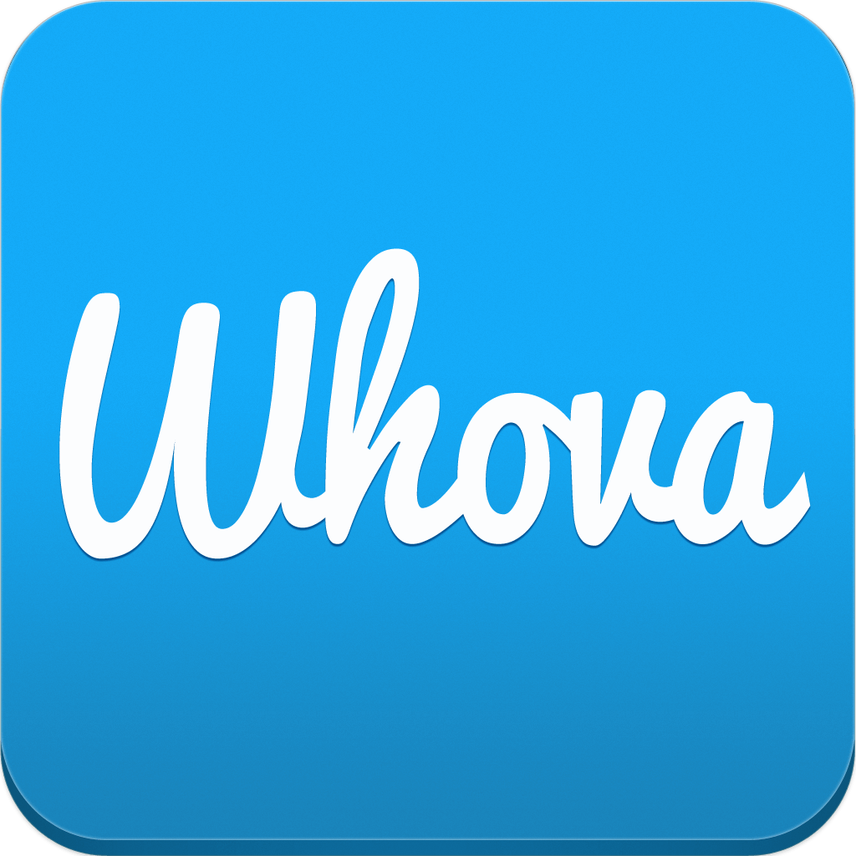

✔ Download Whova to your device! See the email that was sent out on 4/2 for instructions (you’ll need your registration email and a few moments to setup a brief profile).

* This is our official state-of-the-art event guide app designed to maximize your experience.
* Take a quick tour to take advantage of all features (agenda, presentation materials, speaker bios).



**Get Your Social On**

**For a Chance to Win $250!**

Let the world know about all of the fun you are having at the **HR Leaders of Tomorrow** conference by snapping some event selfies and tagging us in your posts! See below for requirements to win:

✔ A student with the **best social media post** will win a ***$250 VISA CASH CARD.***

***✔*** The post must be related to the conference in some way *(e.g. pre-conference travel, corporate visits, networking, conference sessions*) and include 1) the hashtag ***#HRLeaders****of****Tomorrow***, 2) the NHRMA twitter handle ***@NHRMA72***, AND 3) a picture that relates to the post. Posts without pictures are ineligible.

✔ The more posts you make, the more chances you have to win! Extra points for FUN pictures & post!



✔ Expectations are high in terms of level of engagement, professionalism, and ability to remain present.

✔ Be prepared to take notes, commit to grow your network, and dare to develop your own brand.

✔ Share your learning experiences and new friendships on social media! Remember… the $250 prize!

✔ Dress for success at the conference! Business casual is recommended (no jeans or shorts, please).



✔ Bring three (3) copies of your resume AND have your LinkedIn profile updated for review. An HRM professional will examine these items and give you sound tips to improve your branding image.

✔ Collect a business card (or connect on LinkedIn) to continue the conversation after the conference!



✔ Create and/or update your LinkedIn profile BEFORE Saturday 4/7. This will ensure you are prepared to get the most possible out of one of the keynote addresses.

✔ Add new connections along with way and leave the conference with a richer and more diverse network!



✔ With 60+ students traveling from Alaska, Oregon, Idaho and Washington, we want to hear all about your road trips or flights! Be sure to share on social media and remember the $250 prize for best post!

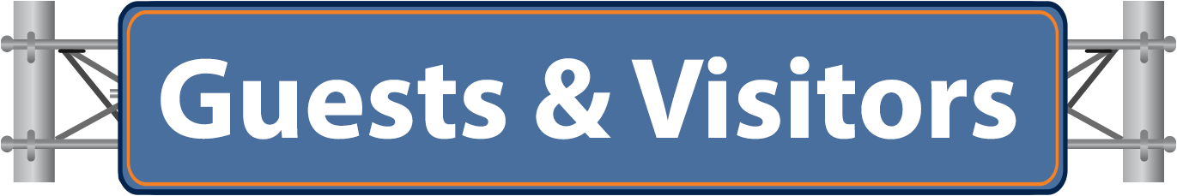

✔ If you signed up for a corporate visit when you registered for the conference, your chapter advisor will be sent all details regarding your assigned company with related transportation logistics for Friday 4/6.

✔ Share your experience on social media and keep that $250 prize in mind!



✔ Be prepared for a fun afternoon of amusement, entertainment and education in a fun environment!

✔ Prizes will be awarded for stellar performance and maybe capture it all on social media!



Weather Report



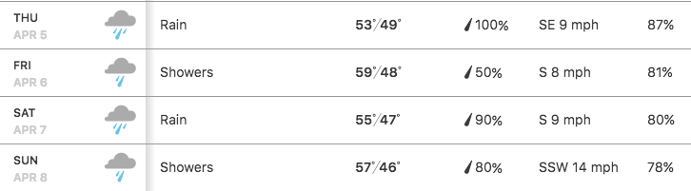

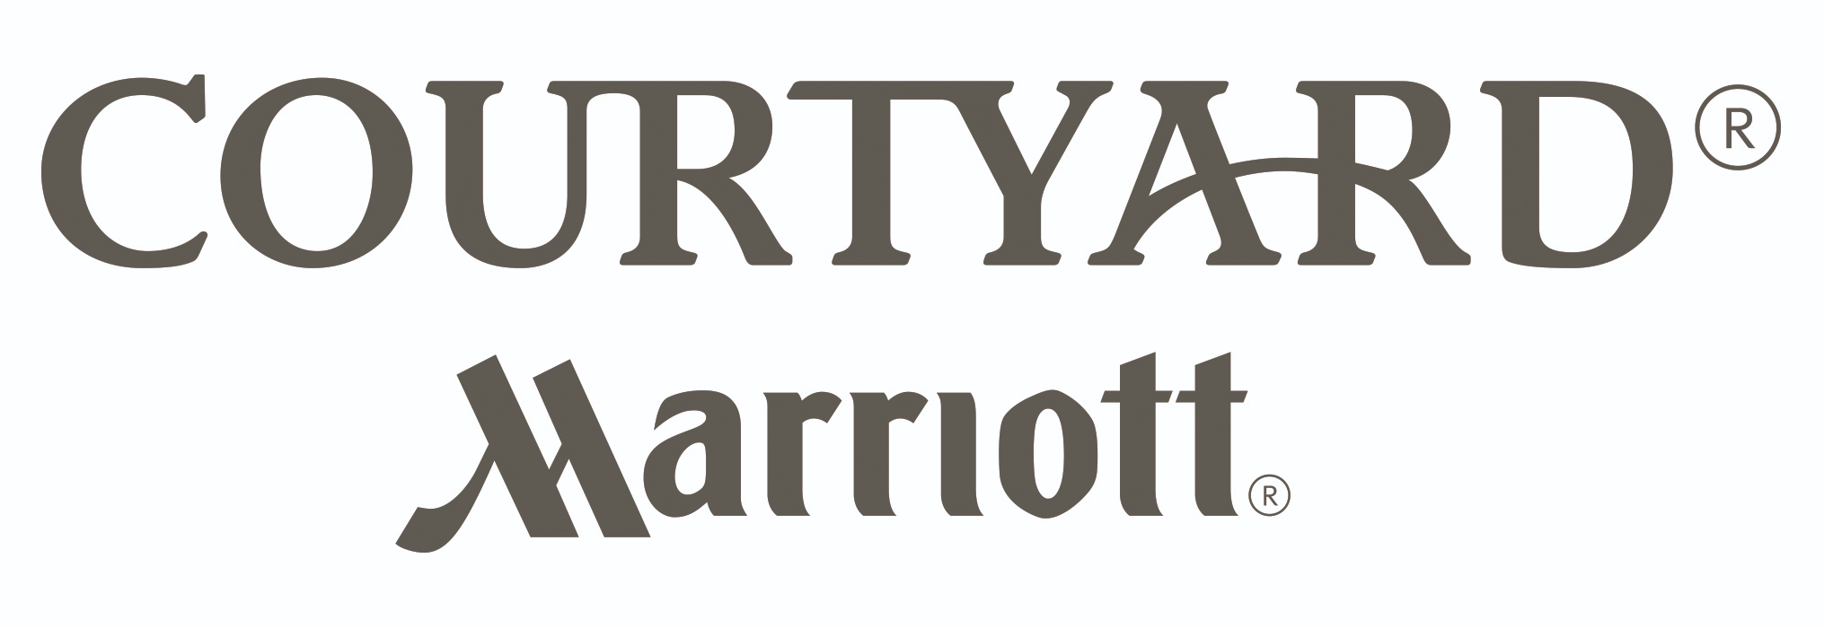

Courtyard Pioneer Square

612 2nd Ave, Seattle, WA 98104

206.625.1111

✔ Click [here](https://www.marriott.com/hotels/maps/travel/seaps-courtyard-seattle-downtown-pioneer-square/) for information about hotel parking (not included) and airport transportation.

✔ Check-in to the hotel upon your arrival and check-in to the conference on Fri 5pm OR Sat 7am.



✔ Bring all of your technology (laptop and mobile device) and don’t forget the chargers!

✔ Share emergency contact information in advance with your advisor.

✔ Meals will be provided at the reception on Friday 4/6 and at lunch on Saturday 4/7 (no breakfast).

✔ For other ways to spend your time outside of the conference, click on the links below:

* [Food & Drink](https://www.visitseattle.org/food-drink/)
* [Top 25 Things to Do in Seattle](https://www.visitseattle.org/things-to-do/sightseeing/top-25-attractions/)
* [Shopping in Seattle](https://www.visitseattle.org/things-to-do/shopping/)
* [Cultural Heritage](https://www.visitseattle.org/things-to-do/arts-culture/cultural-heritage/)

