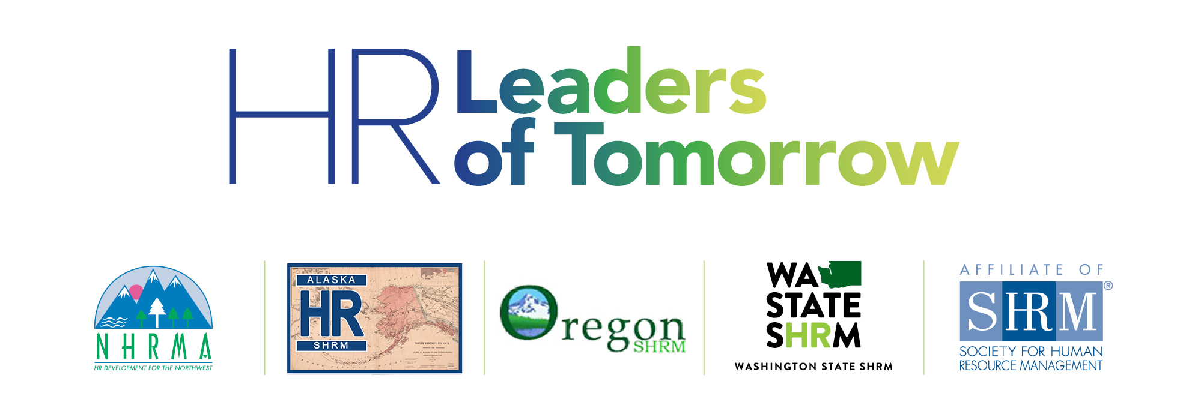

On April 5-6, 2019, the Northwest Human Resource Management Association (NHRMA) and the SHRM State Councils of Alaska, Oregon and Washington will host ***HR Leaders of Tomorrow****,*a premier student conference focused on human resource management. This exciting event will feature corporate HR tours with employers in the Portland area,, keynote addresses by recognized experts in the field, career-building activities designed to develop relationships, and concurrent sessions focused on contemporary HR topics.

**→ PLEASE CLICK** [**HERE**](https://www.eventbrite.com/e/2019-hr-leaders-of-tomorrow-shaping-the-future-tickets-57051075302?aff=eac2) **TO REGISTER ←**

**DATE/TIME/LOCATION**

* Friday April 5 (1:00pm to 8:00pm) and Saturday, April 6 (7:30am - 6:30pm)
* Downtown Portland (University Place Hotel & Conference Center)
* Detailed schedule forthcoming!

**REGISTRATION FEES:**

Includes sessions and several meals:

|  |  |  |  |  |
| --- | --- | --- | --- | --- |
|  | IN-AREA  (Students Currently Residing  Within AK, OR, or WA) | | OUT-OF-AREA  (Students Currently Residing  Outside of AK, OR, or WA) | |
|  | ***EARLY BIRD***  ***By 3/20*** | ***STANDARD***  ***After 3/20*** | ***EARLY BIRD***  ***By 3/20*** | ***STANDARD***  ***After 3/20*** |
| SHRM Student Member | $40 | $60 | *$80* | *$100* |
| Chapter Advisors | $40 | $60 | *$80* | *$100* |
| Non-SHRM Members | $100 | $120 | *$100* | *$110* |

**LOCATION:**

BOOK YOUR ROOM BY 3/20 TO GET EARLY BIRD DISCOUNT RATE!!! The event is being held at the University Place Hotel at 310 SW Lincoln Street in Portland OR 97201. To reserve, call 866-845-4647 and use the group name “NHRMA Student Conference”. Rooms are available with **double** OR **king** beds and some have sofas. Parking is $18/day. More hotel details can be found at www.uplacehotel.com.

**TRANSPORTATION:**

The hotel does not provide airport shuttle service. Travel options from PDX to the hotel include the MAX (public transportation) at $5/day per person, a Lyft/Uber/taxi (~$30/one way), or a rental car.

**TRAVEL SCHOLARSHIPS:**

For student SHRM members and chapter advisors residing in AK, OR or WA, travel scholarships are available to attend the event. Contact Dr. Charla Brown at [cabrown12@alaska.edu](mailto:cabrown12@alaska.edu) for eligibility and dates.

**CONTACT:**

For more information, members of a SHRM student chapter may contact their chapter advisor. Other student SHRM members who are not currently affiliated with a student chapter or anyone that is not a member of SHRM are welcome to contact the following College Relations Directors:

* **Alaska** - Dr. Dave Rambow - [rambowd@wbu.edu](mailto:rambowd@wbu.edu)
* **Oregon** - Scott Lee - [lees@lanecc.edu](mailto:lees@lanecc.edu)
* **Washington** - Markus Smith - [markussmith86@gmail.com](mailto:markussmith86@gmail.com)

*This event is made possible by generous donations from NHRMA, the Alaska State Council, the Oregon State Council, and the Washington State Council, as well as many professional chapters in these states. All contributing sponsors are affiliates of the Society for Human Resource Management (SHRM) and staff representatives from SHRM will be in attendance.*

For reminders and updates, please follow **NHRMA Student Chapter Forum** on Facebook! We also want to see your travel posts, too!!