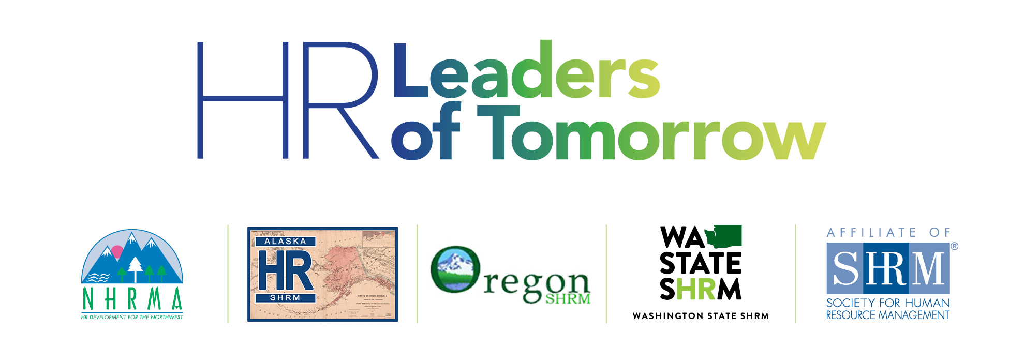

**Student HR Conference**

**Portland, OR**

**April 5-6, 2019**

Hello HR Student Colleagues!

It is with great excitement that we await the conference in Portland just a few days away and we wanted to reach out with some helpful information in advance to help you plan your trip. Please review these details below and if you have any questions at all, please see your chapter advisor or text/call me at 907.465.7272 for assistance. We are confident that this event will be an experience to remember!

In order of priority, please be sure to check out details in the content that follows on subsequent pages:

* Download the Whova conference app to your device to view the agenda & plan your schedule.
* Get your social media on for a **chance to win $100**! The attendee with the best social media post during the week of the conference will ***win $100 VISA CASH CARD!***  See below for details.
* Bring your laptop, mobile device, and three hard copies of your resume for interactive sessions.
* Create a LinkedIn profile before 4/4 to get the most out of the event.
* Share your road trip and/or flight experiences on our Facebook page, NHRMA Student Chapter Forum! This was requested by chapter leaders last year and we want to hear about your journey!
* Get excited for an HR Games showdown (no preparation required). Bring it!
* Pack appropriately for the weather and the event - business casual, please (no jeans/shorts).
* Find out more about your corporate tour experience scheduled for Friday 4/5 (if applicable).
* Be prepared to build your network, make new friends, and have a great learning experience!

See you soon and safe travels!!

**Charla**  Alan

Charla Brown, PhD Alan Cabelly, PhD

NHRMA College Relations Director NHRMA Special Projects Director

Conference Committee Co-Chair Conference Committee Co-Chair

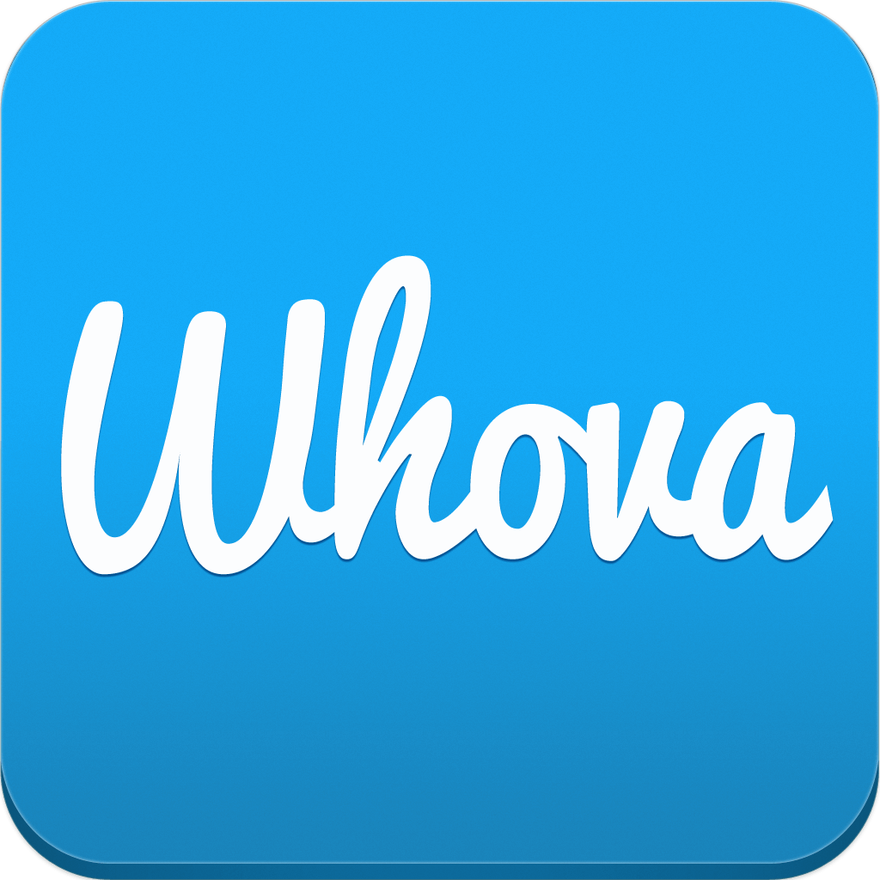

✔ Download Whova to your device! See the email that was sent out this week for instructions (you’ll need your registration email and a few moments to setup a brief profile).

* This is our official state-of-the-art event guide app designed to maximize your experience.
* Take a quick tour to learn about all features (agenda, presentation materials, speaker bios).



**Get Your Social On**

**For a Chance to Win $100!**

Let the world know about all of the fun you are having at the **HR Leaders of Tomorrow** conference by snapping some event selfies and tagging us in your posts! See below for requirements to win:

✔ A student with the **best social media post** will win a ***$100 VISA CASH CARD.***

***✔*** The post must be related to the conference in some way *(e.g. pre-conference travel, corporate visits, networking, conference sessions*) and include 1) the hashtag ***#HRLeaders****of****Tomorrow***; 2) the NHRMA twitter handle ***@NHRMA***; AND 3) a picture that relates to the post. Posts without pictures are ineligible.

✔ The more posts you make, the more chances you have to win! Extra points for FUN pictures & post!



✔ Expectations are high in terms of level of engagement, professionalism, and ability to remain present.

✔ Be prepared to take notes, commit to grow your network, and dare to develop your own brand.

✔ Share your learning experiences and new friendships on social media! Remember… the $100 prize!

✔ Dress for success at the conference! Business casual is recommended (no jeans or shorts, please).



✔ Bring three (3) copies of your resume AND have your LinkedIn profile updated for review. An HR professional will examine these items and give you sound tips to improve your branding image.

✔ Collect a business card (or connect on LinkedIn) to continue the conversation after the conference!



✔ Create and/or update your LinkedIn profile BEFORE the event so you can connect right away!



✔ With 50+ students traveling from Alaska, Oregon, Idaho and Washington, we want to hear all about your road trips or flights! Be sure to share on social media and remember the $100 prize for best post!

✔ Check out our Facebook page, **NHRMA Student Chapter Forum** to share you travel experiences.

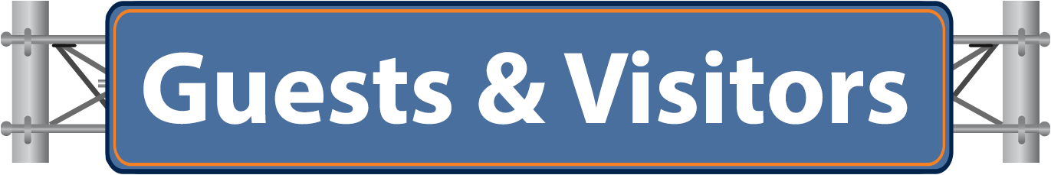

✔ If you signed up for a corporate visit when you registered for the conference, your chapter advisor has been sent all of the logistical details for Friday 4/5. Here is a list of all the companies that are participating:

* Portland General Electric - WBU, UAS, APU and WGU
* Reser’s - LWT
* iovation - OSU
* Elephant’s Delicatessen - UAF
* Lewis & Clark - PSU

✔ Share your experience on social media and keep that $100 prize in mind!

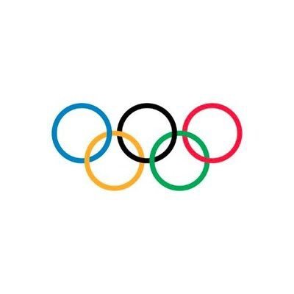

✔ Be prepared for a fun afternoon of amusement, entertainment and education in a fun environment!

✔ Prizes will be awarded for stellar performance and maybe capture it all on social media!

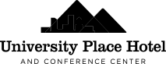

310 SW Lincoln Street - Portland, OR - 97201

503-221-0140

✔ Check-in to the hotel upon your arrival and check-in to the conference on Fri 5pm OR Sat 7am.



✔ Bring all of your technology (laptop and mobile device) and don’t forget the chargers!

✔ Share emergency contact information in advance with your advisor.

✔ Meals will be provided - this includes a reception on Friday 4/5 and breakfast/lunch on Saturday 4/6.

✔ For other ways to spend your time outside of the conference, see the attached document!

