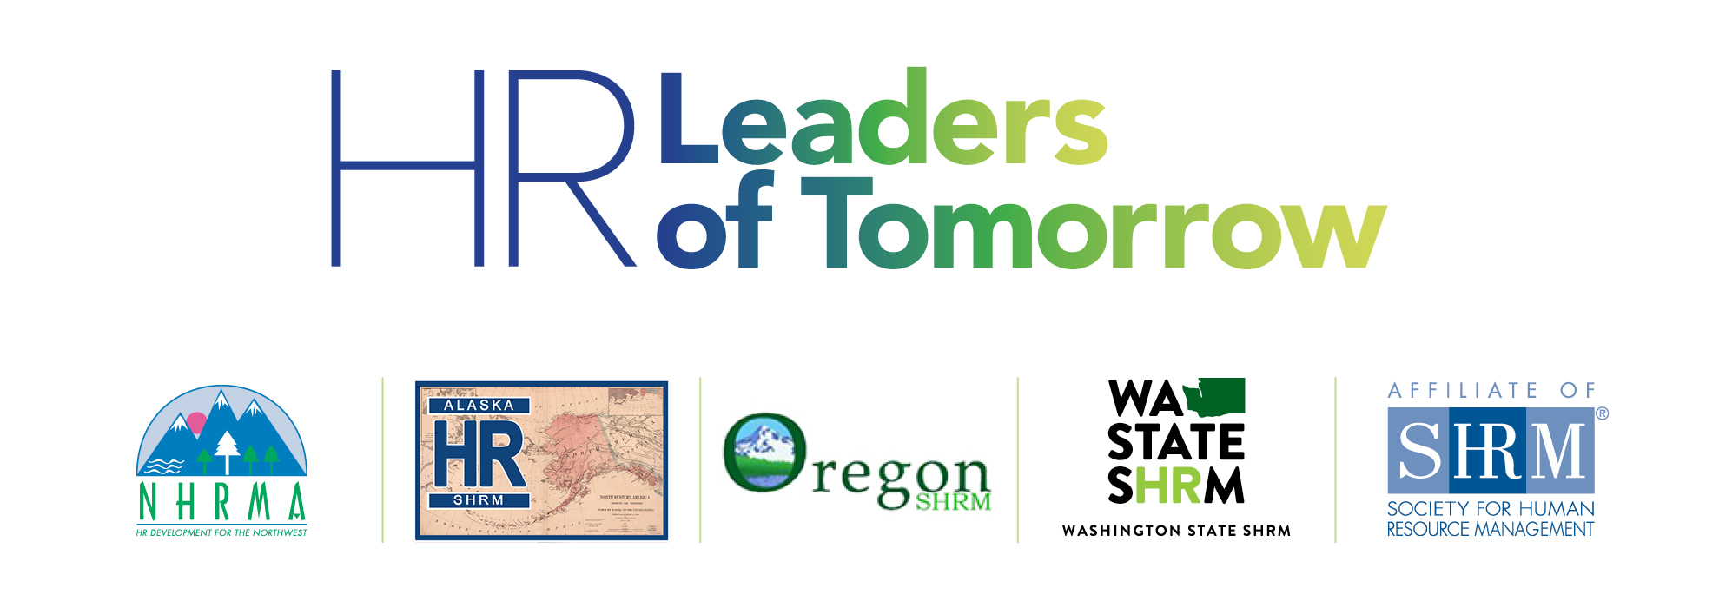

On April 6-7, 2018, the Northwest Human Resource Management Association (NHRMA) and the SHRM State Councils of Alaska, Oregon and Washington will host ***HR Leaders of Tomorrow****,*a premier student conference focused on human resource management. This exciting event will feature corporate HR tours with employers in Seattle,, keynote addresses by recognized experts in the field, career-building activities designed to develop lasting relationships, and concurrent sessions focused on contemporary HR topics.

**→ PLEASE CLICK** [**HERE**](https://www.eventbrite.com/e/hr-leaders-of-tomorrow-tickets-43690348007) **TO REGISTER ←**

**DATE/TIME/LOCATION:**

|  |
| --- |
| * Friday April 6 - 1:00pm to 8:00pm * Saturday, April 7 - 7:30am - 6:30pm * Downtown Seattle (Courtyard Seattle Downtown/Pioneer Square) * Detailed schedule forthcoming! |

**REGISTRATION FEES:**

Includes sessions, 2 meals (heavy hors d'oeuvres 4/6 & lunch 4/7) and transportation for corporate tours.

|  |  |  |  |  |  |  |
| --- | --- | --- | --- | --- | --- | --- |
|  | IN-AREA  (Students Currently Residing  Within AK, OR, or WA) | | | *OUT-OF-AREA*  (Students Currently Residing  Outside of AK, OR, or WA) | | |
|  | ***Before 3/23*** | *Between 3/23-4/5* | *Day of*  *4/6-4/7* | *Before 3/23* | *Between 3/23-4/5* | *Day of*  *4/6-4/7* |
| SHRM Student Member | **$35** | $55 | $75 | *$75* | *$95* | *$115* |
| Chapter Advisors | **$35** | $55 | $75 | *$75* | *$95* | *$115* |
| Non-Members | **$65** | $85 | $105 | *$100* | *$120* | *$140* |

**ACCOMMODATIONS:**

Courtyard Seattle Downtown/Pioneer Square - 612 2nd Avenue, Seattle WA - (206) 625-1111

GROUP CODE: "HR NHRMA SHRM CON"- [**BOOK HERE**](http://www.marriott.com/meeting-event-hotels/group-corporate-travel/groupCorp.mi?resLinkData=SHRM%20Northwest%20Student%20Conference%5Eseaps%60NWRNWRA%60125.00%60USD%60false%604%604/4/18%604/9/18%603/16/18&app=resvlink&stop_mobi=yes) **before 3/15 for group rate ($125/night + tax)**

**TRANSPORTATION:**

Options to/from SEA-TAC airport include: 1) The Link light rail (35 minutes plus fare), 2) Lyft (30 minutes plus ~$36/one-way, or 3) a taxi ride at $52/one way. The hotel does not provide airport shuttle service.

**TRAVEL SCHOLARSHIPS:**

For student SHRM members and chapter faculty currently residing in AK, OR or WA, scholarships are available if travel is required to attend the event. **For application information, eligibility and selection criteria, please contact Dr. Charla Brown at cabrown12@alaska.edu/907.465.7272 by 3/12.**

**CONTACT:**

For more information, members of a SHRM student chapter may contact their chapter advisor. Other student SHRM members who are not currently affiliated with a student chapter or anyone that is not a member of SHRM are welcome to contact the following College Relations Directors:

* **Alaska** - Dr. Dave Rambow - [rambowd@wbu.edu](mailto:rambowd@wbu.edu)
* **Oregon** - Laurie Leriche - [laurie.leriche2@oregonstate.edu](mailto:laurie.leriche2@oregonstate.edu)
* **Washington** - Juanita Roesler [juanita.roesler@pb.com](mailto:juanita.roesler@pb.com)

*This event is made possible by generous donations from NHRMA, the Alaska State Council, the Oregon State Council, and the Washington State Council, as well as many professional chapters in these states. All contributing sponsors are affiliates of the Society for Human Resource Management (SHRM) and staff representatives from SHRM will be in attendance.*

For reminders and updates, follow **NHRMA - Northwest Human Resource Management Association** on Facebook!