# **2015 Alaska HR Academy Survey Results:** Feb 2-5, 2015

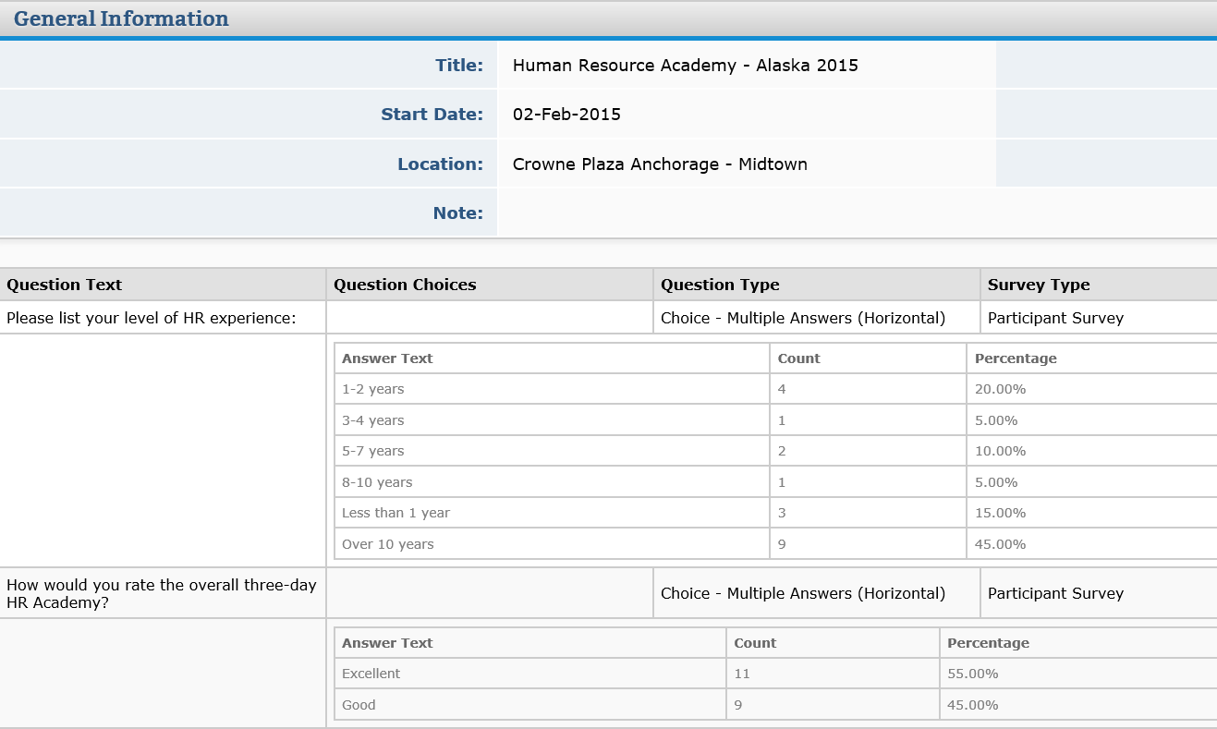

Please rate the content of the presentations

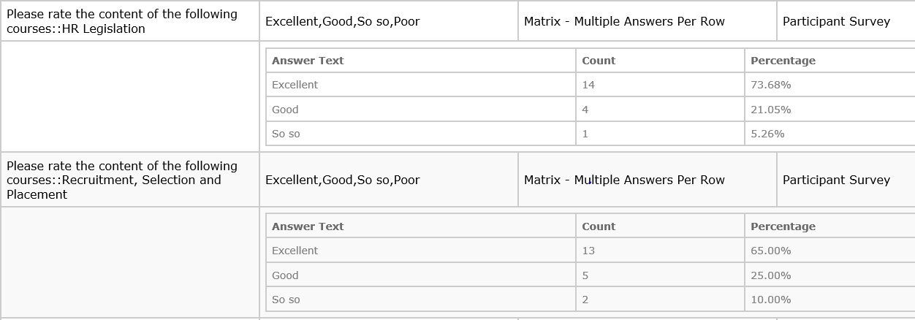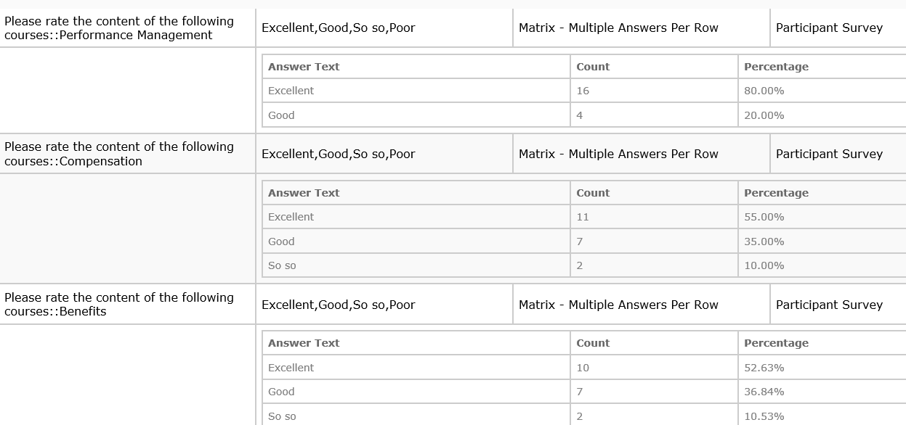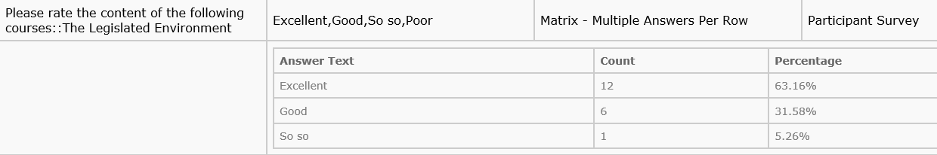

Please rate the speakers

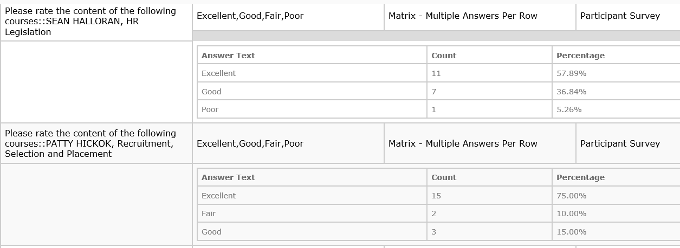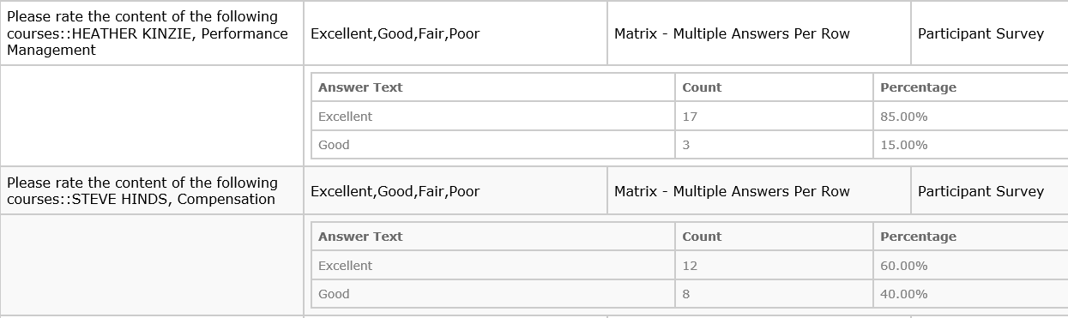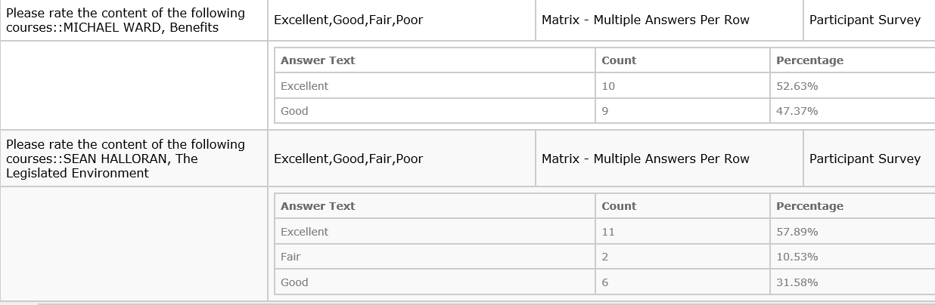

Please rate the following items related to the HR Academy

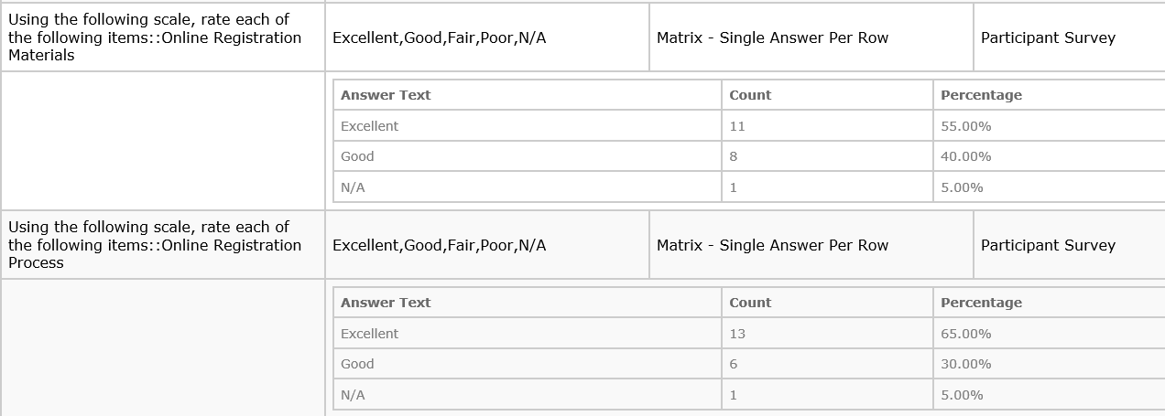

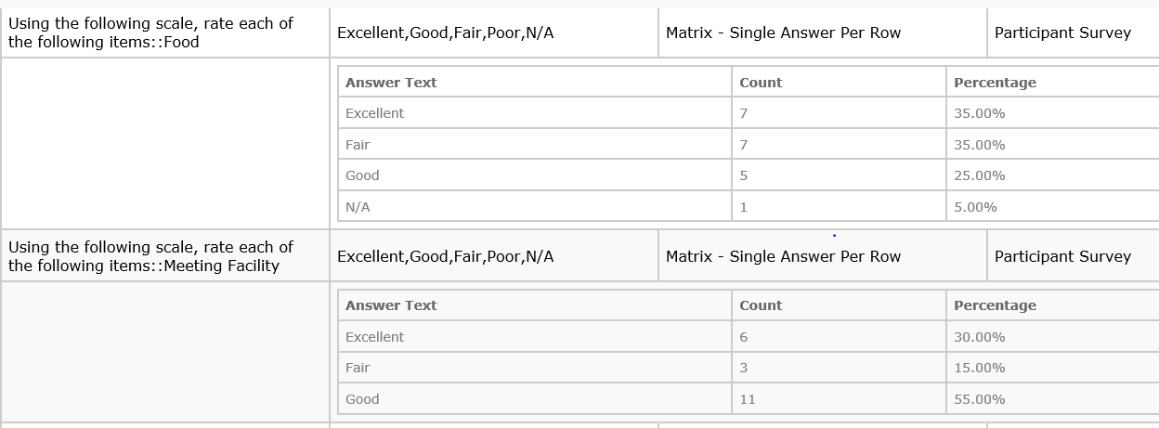

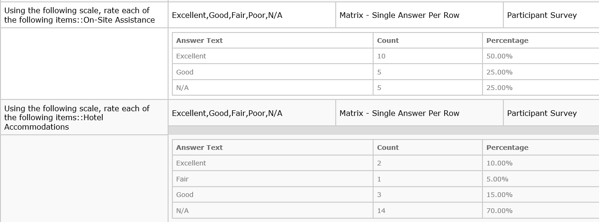

What did you like about the HR Academy?

Answer

* The Academy was surprisingly good, all the speakers were excellent and I enjoyed it very much
* this was not geared for entry level HR professionals, which was greatly appreciated.
* I liked all the information given by the speakers.
* The Academy provided multiple talented speakers. I liked the time of year this event was held and the schedule followed throughout the day.
* The information was excellent, the speakers were great, and it was great to connect with HR people from all around the state.
* I liked the fact that you are talking about current topics in the HR world and getting input from others on the impact it is going to have, as well as sharing ideas, solutions, etc.
* The conference wasn't overcrowded. Enjoyed each speaker and the information presented.
* "I liked it that each subject had more time than to just go over the what and why - but also some of the how.
* Although I am a long-time HR person and know much of the material, I did get some specifics, differing points of view and reminders, which can only help.
* For me the Compensation was specifically useful, as well as the legislative updates and impact.
* Unfortunately I missed the benefits subject due to competing priorities.
* I thought the topics were diverse and very good to know, especially for newer HR professionals. The food was EXCELLENT, minus a day without an afternoon snack! :) I would have liked a larger beverage selection.
* "Location was good. Good value, for the price paid. Good variety of topics. The dual-sided recertification credit handout was awesome."
* Over all it was good information, good food and good networking opportunities.
* Went more in depth on topics, networking.
* I did learn a few things.
* I enjoyed how the speakers engaged the participants and that the conference was in town.
* The sessions were long enough to get very good information and feedback, as well as time to hear from others on their situations. This was a much better then the seminars, because there is time to hear from others and give examples of situations that we face.
* "All speakers were very knowledgeable and able to handle questions/scenarios well
* Appreciated speakers including dynamic, interactive presentations (e.g group activities, throwing questions back out to the participants, etc.)
* Great training for new and seasoned HR professional"
* A lot of useful information for a new person in HR

How can the HR Academy be better?

* Better breakfast
* The only complaint I have is the class was cold! Half the attendants wore coats and scarves on the second and third days.
* Even though the slides were "green" many people printed them anyway which defeated the purpose. Suggest encouraging attendees to bring their electronics to view the slides rather than print.
* I wished Sean Halloran made his session more interactive. His information is always great but after 2 hours of listening, it gets really hard to pay attention.
* Better temperature control in the meeting room. The first and third days were hot, the second day was cold.
* Room temperature was erratic (I know that NHRMA does not have control over that - but worth a mention).
* I think it would be great for groups of that size and smaller to have everyone go around the room and introduce themselves as a bit of an ice breaker. Not everyone attending works in Anchorage and it would be more welcoming.
* Adding more about public institutions...we are very different than private organizations and so some of the material was not relevant. Plus, you are feeding us...so we are a captive audience...give us a 30-minute break and keep the afternoon speaker going so we can get done earlier. Talk more about a unionized environment and those issues.
* The room was crowded, it would have been nicer with a square room so that some of the people didn't have to sit so far back.
* There were times when we didn't have a break. Too long of sitting hurts me. So I had to get up or even go use the restroom. I was afraid to miss some good knowledge.
* This was my first conference I attended for HR so I truly enjoyed myself.
* Better food, otherwise it was great!
* Sean Halloran's presentations were very informative but long; recommend that he either take a short break and/or include some interactive pieces (e.g. group discussions)
* Maybe more breaks during presentations. It is a lot of information but having at least 10 minutes to stand and stretch your legs really makes a difference to come back and focus on what is being presented.

Additional comments

* If they choose to send me again I will certainly go!
* The food provided by Crowned Plaza contained Nuts...without notice to us. With the many Allergies People have nowadays, had I not had my epi-pen and asked staff, it could have been tragic.
* Please put me on your list for information on upcoming events, meetings, etc. Thanks so much for a really fabulous conference.
* I feel like the compensation speaker was very educated and gave a great presentation however I feel that maybe a more general overall presentation of compensation would be more beneficial as you have attendees of all different sub departments in HR, ie: not everyone is in a department of creating a wage structure.
* I think presenters like Heather Kinzie is very helpful when having long presentations like that. It was great to have interactive work within the groups as well
* Room was too cold many times during presentations.
* Sean Halloran needs to not be so disrespectful regarding his political views. Not one time did he say President Obama...he used Barack Obama several times which very obviously lends itself, as well as his voice inflections, as to his political views. The Monday session wasn't as bad, but the Wednesday session had me so frustrated I stopped listening to him because it was obvious he's not a fan of the President. He made inferences to the President making all kinds of policy on his own when in fact EVERY president has written executive orders, and President Obama has written FEWER than other recent presidents! Not to mention his use of the "n-word" and the "f-word" which even in the context of the story was inappropriate. I liked a majority of his content as he used great examples, but even though the employees may have actually used these offensive words, Sean didn't need to and we still would have gotten the message.
* "I rated the HR Legislation session low. That presentation was very offensive. Sean's use of the ""F"" word, the ""N"" word, and multiple disparaging remarks, and examples, using BLACK people, and President Obama was derogatory, and again, OFFENSIVE. Several people at our table cringed. BTW, all BLACKS in Detroit, don't have a criminal record. There are HUNDREDS of other races in the world, yet, he seemed obsessed with BLACKS. Horror stories aren't isolated to one group or another, so the use of multiple examples would have been more effective. This effected his credibility. Second, the temperature in the room was too COLD. It was almost unbearable. Lastly, the e-mail reminder, and slides, did not reach all participants. It was frustrating, to not have gotten a chance to look at the information, before attending the academy. In the future, please double check the distribution list. A lot of people didn't get those e-mails, and they weren't in Junk, or Spam folders.
* I look forward to attending and to meeting many of the HR professionals and hope to learn as much as I can.
* Thank you for this opportunity, I learned a lot and will be able to use all of the information at some time. I especially made not of situations that we need to improve upon with the information that we had received.

*Context: the attorney was quoting from a case he was using as an example. The same two people that commented on the attorney’ comments are the same that rated sessions, presenters, food and all the items so-so or fair. Both work for the same local government office in the MatSu Valley.*